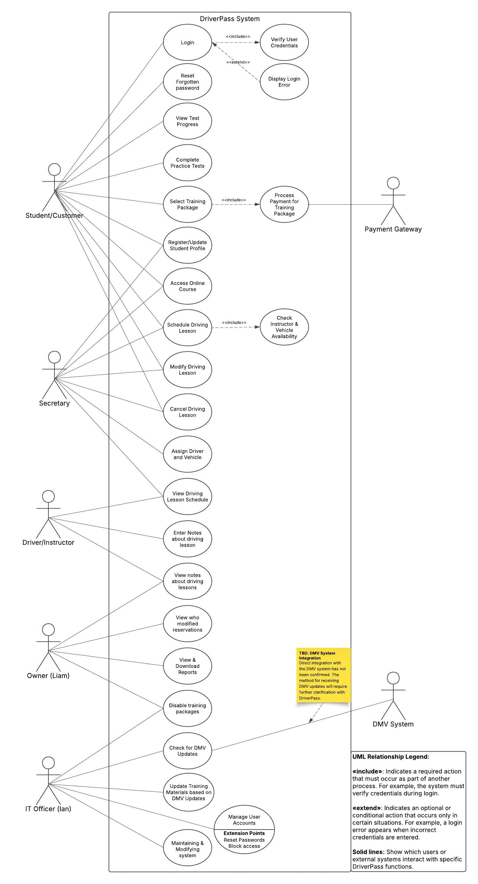
CS 255 System Design Document

UML Use Case Diagram

The UML Use Case Diagram illustrates how customers, employees, and external systems interact with the proposed DriverPass system. Customers can manage their accounts, select training packages, complete practice tests, track progress, and schedule driving lessons. Employees can manage reservations, assign instructors and vehicles, record lesson notes, generate reports, and maintain system information. The diagram also identifies payment processing and potential DMV integration. By defining each user's responsibilities, the design helps DriverPass organize daily operations, improve customer service, and control access to system functions.

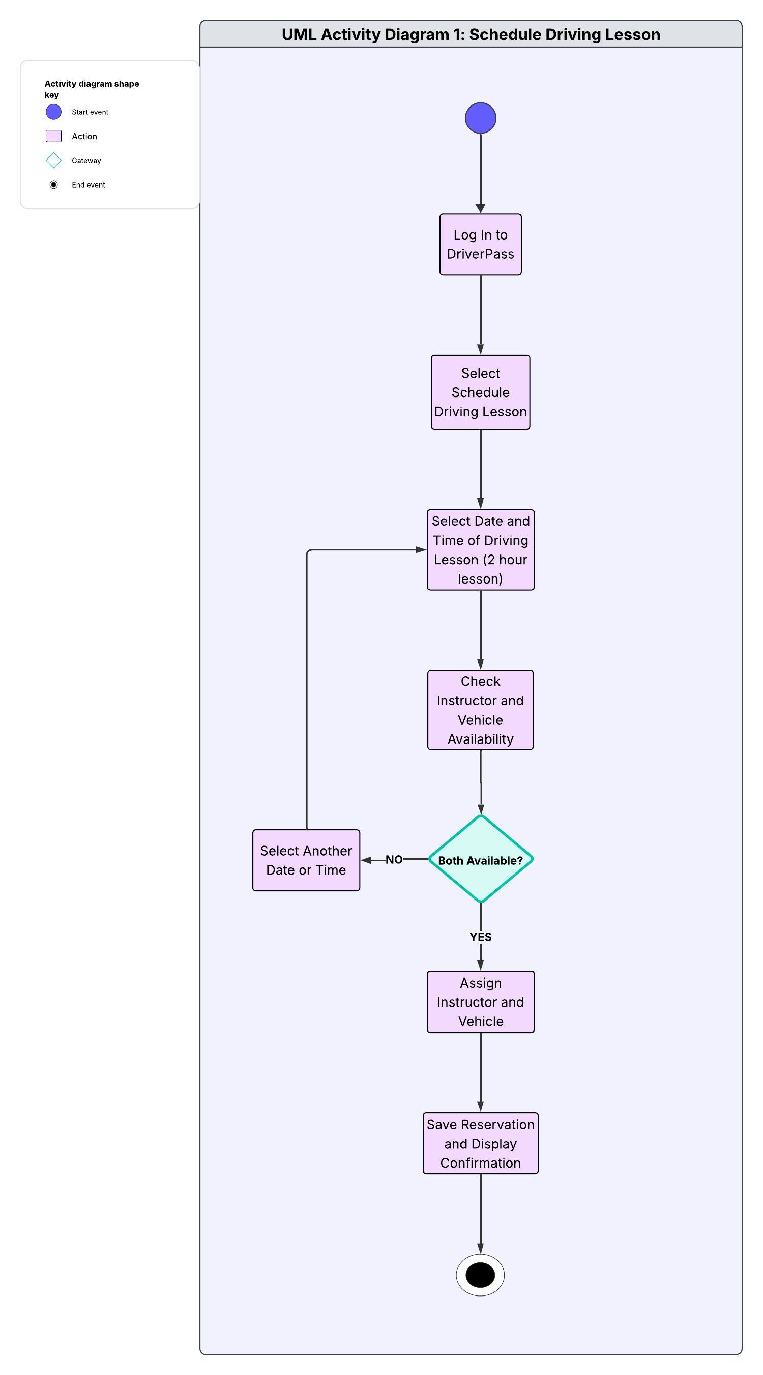
UML Activity Diagrams

UML Activity Diagram 1: Schedule Driving Lesson

The Schedule Driving Lesson activity diagram illustrates the steps required for customers or authorized DriverPass employees to schedule an on-the-road driving lesson. After logging in, the user selects the scheduling option and chooses a date and time for a two-hour lesson. The system checks the availability of both the instructor and vehicle before allowing the reservation to proceed. If either is unavailable, the user must select another date or time. When both are available, the system assigns the instructor and vehicle, saves the reservation, and displays confirmation. This process supports DriverPass's scheduling requirements by preventing overlapping reservations and maintaining accurate lesson information.

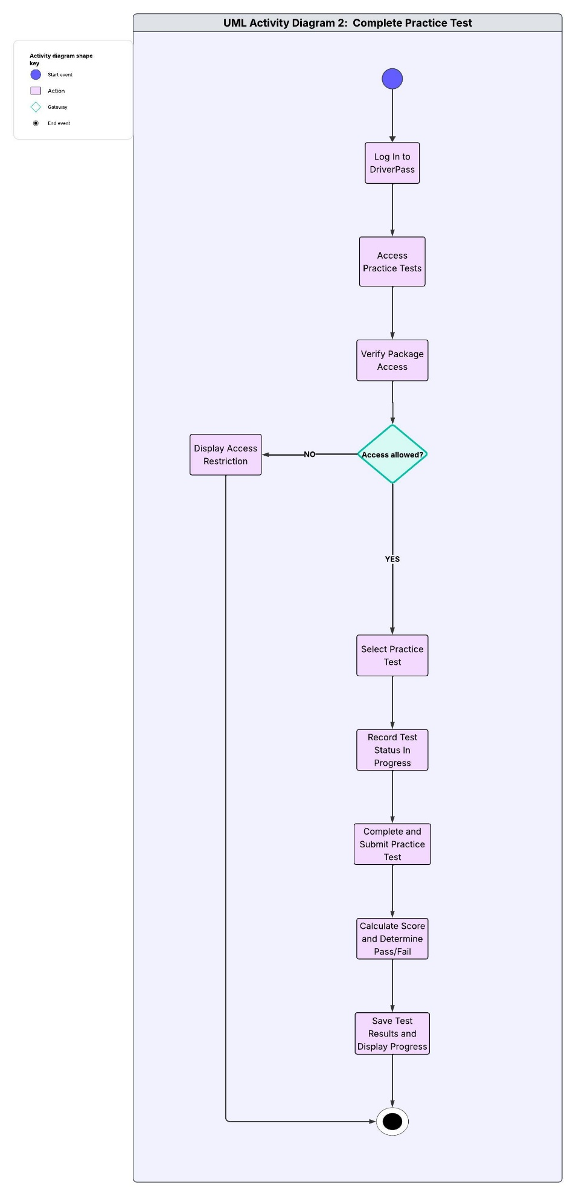
UML Activity Diagram 2: Complete Practice Test

The Complete Practice Test activity diagram illustrates how students access and complete online practice tests through the DriverPass system. After logging in, the student selects the practice testing function, and the system verifies whether the student's training package includes access to practice tests. If access is restricted, the system displays a notification and ends the activity. If access is permitted, the student selects a practice test, and the system records the test status as in progress. Once the student completes and submits the test, the system calculates the score, determines whether the student passed or failed, and saves the results. Students can then view their progress, monitor their performance, and identify areas that may require additional practice. This process supports DriverPass's goal of helping students prepare for their driving examinations while maintaining accurate progress records.

UML Sequence Diagram

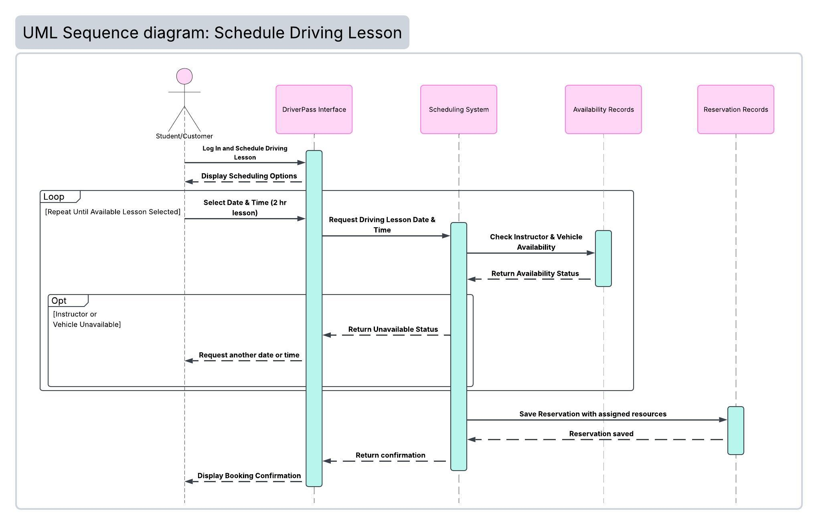

The Schedule Driving Lesson sequence diagram illustrates the interactions between the customer and the different components of the DriverPass system when scheduling a two-hour driving lesson. The customer begins by logging into DriverPass and accessing the scheduling function. After selecting a preferred date and time, the DriverPass interface sends the request to the scheduling system, which checks instructor and vehicle availability. If either resource is unavailable, the system prompts the customer to select another appointment time, and the process repeats until it finds an available lesson. Once both resources are available, the system saves the reservation with the assigned instructor and vehicle and displays booking confirmation. This design supports DriverPass's requirements for accurate scheduling, efficient resource management, and preventing overlapping reservations.

UML Class Diagram

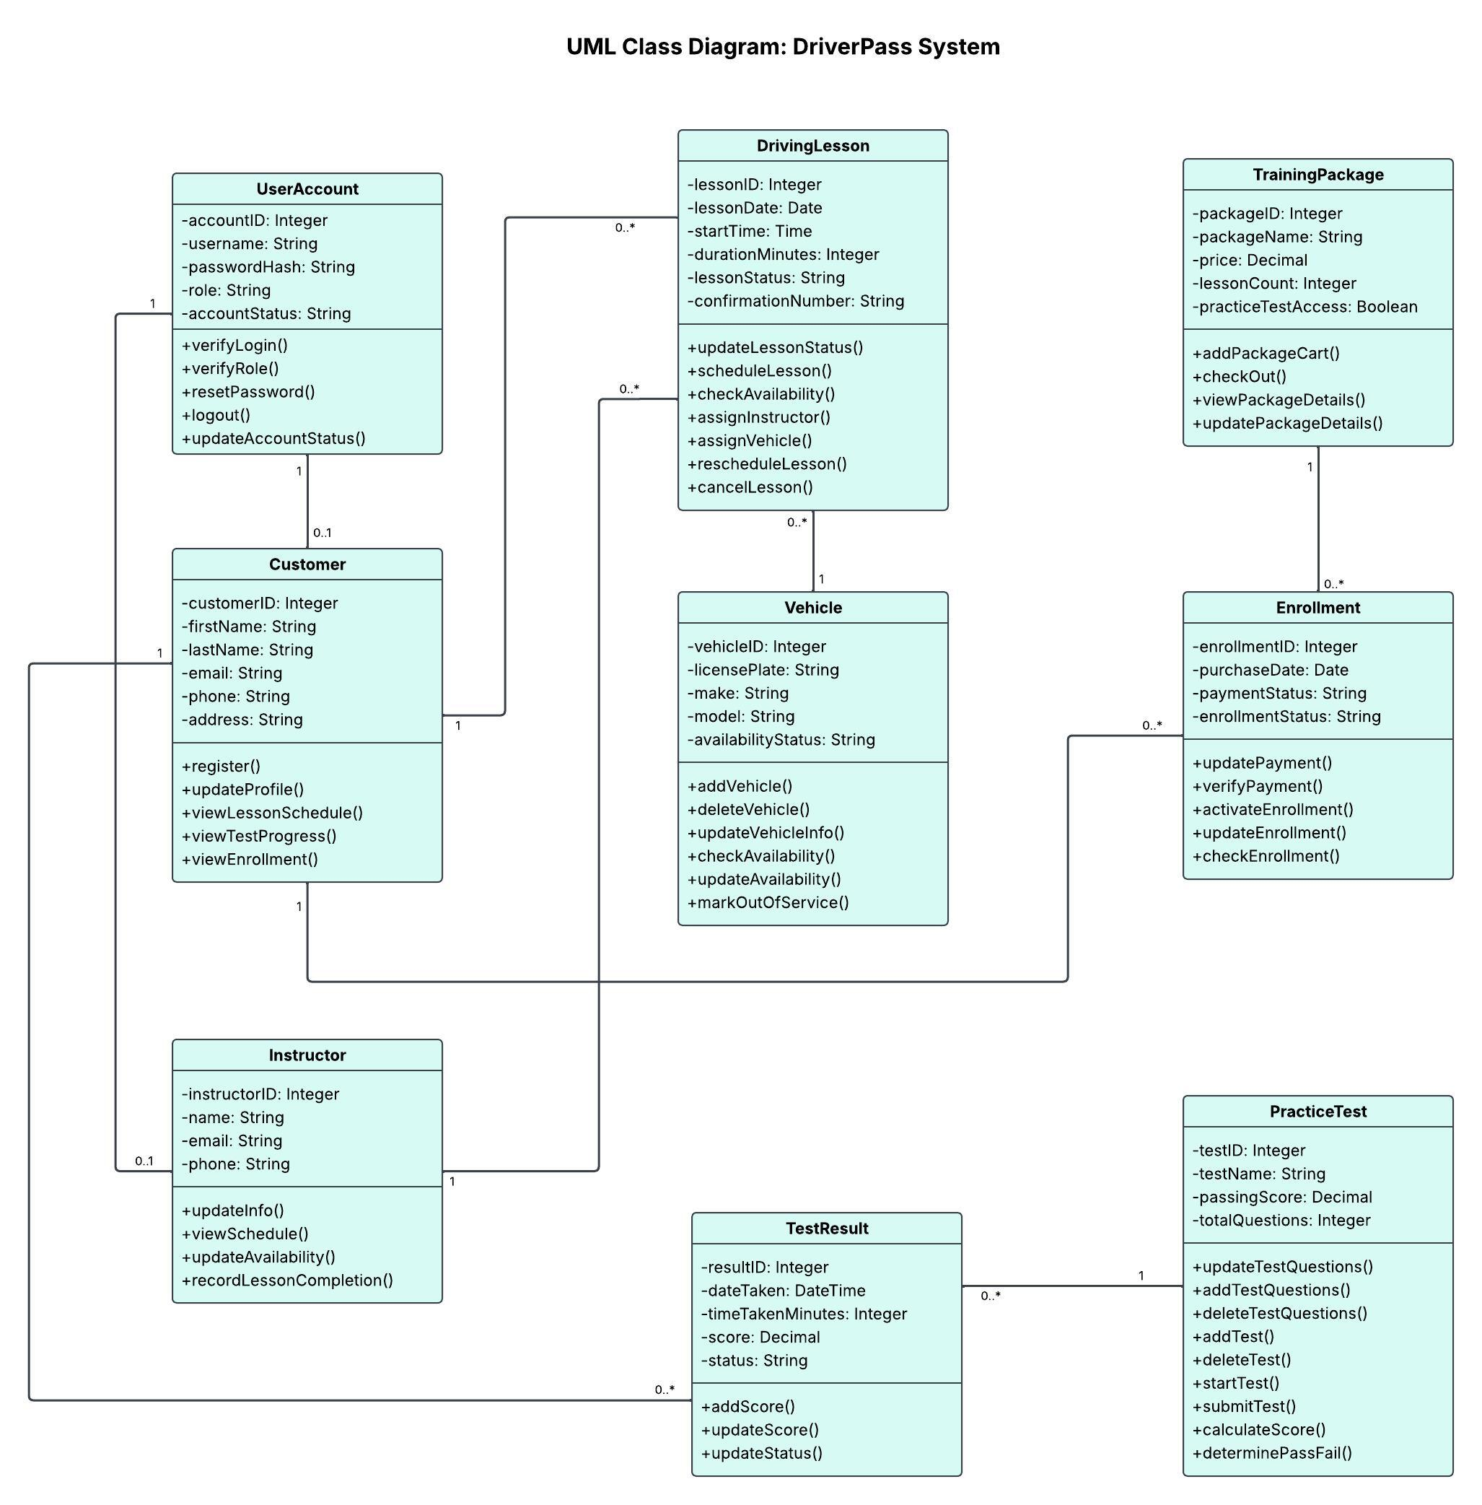

The UML class diagram illustrates the nine primary classes of the DriverPass system, including their attributes, methods, and relationships. These classes support account management, driving lesson scheduling, instructor and vehicle availability, training package enrollment, and practice testing. Relationships and multiplicities show how the classes connect and share information. This object-oriented design organizes system functions into manageable components, allowing developers to build, maintain, and expand the system while meeting DriverPass's business requirements.

Technical Requirements

Hardware Requirements
The DriverPass system will require internet-connected computers or laptops for the owner, secretary, IT officer, and other authorized employees to manage customer accounts, reservations, training materials, and administrative reports. Instructors will need access to computers or mobile devices to review assigned lessons and record lesson information, including start and end times and comments. Customers will need an internet-connected computer, tablet, or smartphone to register, purchase training packages, schedule driving lessons, and access eligible online training materials. The system should use cloud-hosted servers to provide centralized processing and data storage without requiring DriverPass to maintain physical servers at its location. The initial system must support scheduling and record management for the company's 10 vehicles and assigned instructors.

Software Requirements
DriverPass will require a web-based application that operates through compatible desktop and mobile browsers. A centralized relational database management system, such as MySQL or PostgreSQL, will store customer profiles, user accounts, training packages, enrollments, reservations, instructor and vehicle information, lesson notes, practice test results, and reservation activity history. The application must support role-based access controls, secure authentication, password resets, and account deactivation. Scheduling software must check instructor and vehicle availability, prevent overlapping reservations, and support two-hour driving lessons, including modifications and cancellations. The system must also provide online learning and practice testing based on package eligibility, process payments through a secure payment service, support administrative reporting, and provide downloadable reports compatible with Microsoft Excel. Authorized employees must be able to update training materials, practice questions, and DMV information without changing the application's code.

Development Tools
Developers will require software development tools to design, implement, test, and maintain the DriverPass application. Lucidchart will be used to create and maintain UML diagrams, while an integrated development environment, such as Visual Studio Code, will support application development. GitHub can provide version control and collaboration throughout development. Database management tools will support the creation and maintenance of system records. Automated and manual testing tools will be needed to verify account permissions, scheduling accuracy, package access, payment functionality, practice test scoring, and reservation activity tracking. Testing must also confirm that customers and employees cannot access unauthorized information or create conflicting reservations.

Infrastructure Requirements
DriverPass will require reliable internet connectivity and a cloud-hosted infrastructure that provides centralized access to the application and its database. The hosting environment should support multiple simultaneous users, secure HTTPS connections, encrypted storage, firewalls, and regular backups. Role-based permissions and audit logging must protect customer information and record reservation changes. The system should include monitoring, recovery procedures, and scalable resources to maintain reliable operation as the business grows. Changes to centralized records will require an internet connection, although authorized users may download reports for offline use. Direct integration with DMV systems will remain a potential future enhancement until technical requirements and access permissions are confirmed. We will need to further evaluate and obtain client approval for specific hosting providers, performance targets, uptime expectations, and payment processing arrangements before implementation.

References

Lucid Software Inc. (n.d.-a). Activity diagram tutorial. https://www.lucidchart.com/pages/uml-activity-diagram

Lucid Software Inc. (n.d.-b). Class diagram tutorial. https://www.lucidchart.com/pages/uml-class-diagram

Lucid Software Inc. (n.d.-c). Sequence diagram tutorial. https://www.lucidchart.com/pages/uml-sequence-diagram

Lucid Software Inc. (n.d.-d). UML use case diagram. https://www.lucidchart.com/pages/uml-use-case-diagram

Southern New Hampshire University. (n.d.). CS 255 thinking through technical requirements [Course PDF]. https://learn.snhu.edu/content/enforced/2377277-CS-255-12578.202681-1/course_documents/CS%20255%20Thinking%20Through%20Technical%20Requirements.pdf?ou=2377277

